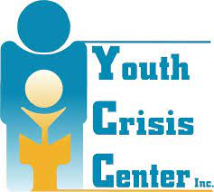
Crisis Shelter Handout

The Youth Crisis Center (YCC) crisis shelter is open 24 hours a day, 7 days a week, to assist any family during a crisis. Services include providing shelter and basic needs for youth who unable to remain safely in the home or do not have a place to stay.

Case Management and Prevention Services
YCC offers the following to assist youth and families in crisis within the first 72 hours:
- Family Meeting: meet with a case manager to work through challenges, set goals, and address family needs.
- Individual Meetings: youth meet with a case manager to create a plan with individualized goals.
- Safety Plans: youth and/or families work with a case manager to address safety concerns and promote positive methods for preventing crisis.
- Referrals/Access to Services: connect with other agencies and complete the first steps to begin services.

Permissible Items and Personal Belongings
Please provide the following for your child during their stay:
- A few pairs of comfortable clothing that follow the Natrona County School District’s dress code. (No strings)
- At least 10 days worth of any medication they take is required.
- Their school backpack.
Items NOT allowed: outside food or drink; clothing with strings, ribbons, ties; any form of electronics; shoes are not worn in the facility; personal shampoo, soap, hygiene products; and any item(s) deemed unnecessary or dangerous by Crisis Center staff.
The Youth Crisis Center shall not be responsible for personal items. All items in the facility or on premises after 30 days from date of departure/service (including money) will be donated, thrown out, or become property of YCC.

Phone Calls and Visits
Only approved contacts are able to communicate with the youth or receive any information from the Youth Crisis Center, Inc. team. Please note the following regarding phone calls and visits:
- Youth may place calls to DFS worker, parents, and attorney each day with permission from staff. All others must be pre-approved by case manager/supervisor and legal guardian. Youth may not be permitted to contact friends.
- Youth are not allowed calls or visits during meals, study hour, chores, groups, meetings, or sleep hours. Youth may only be allowed one visit per week due to limited availability of time, space, and staffing.
- All visits will be scheduled in advance due to limited availability of space and staff to monitor visits.
- Length of visits is 30 minutes or less and may be cut short if staff requests.
- Visits that include more than two visitors must be pre-approved by a case manager or the GHPS.
- Anyone under the age of 18 must be related to the resident in order to visit. In addition, they must be preapproved by the legal guardian and an adult must be present during the visit.
- Outside food and beverages are not allowed during visits.
For a complete list of visit expectations, request to view the Youth Crisis Center In-House Visits form.

School
The crisis shelter supports the education of youth in our center. Guardians consent to the following at entry:
- I understand YCC staff will take youth to and from school.
- I am aware the drop-off and pick up location is the same. Youth must be in this location at the time of pick-up.
- I am aware that youth may not accept a ride from anyone other than YCC staff.
- I am aware that youth are to stay on school grounds at all times and attend all classes.
- I understand my child will participate in the YCC Day Resource Program if he/she is not in school during the day.
- I am aware that youth who are sick (fever of 100° or higher and/or throwing up) and do not go to school will be placed on sick status and remain in their room all day and evening.

Length of Stay
The guardian of the child will be contacted by a case manager to develop a plan for depart. Generally, contact is made within 72 hours. Guardians may also pick up the child at any time. Please note:
- Services/program may be terminated for any number of reasons, including failure to meet expectations as outlined in the client rights and responsibilities, failure to meet program expectations and requirements, failure to meet criteria for services, lack of participation/progress, or agency inability to provide appropriate services.
- Guardians consent to the following at entry:
  - As the parent/guardian, I understand I am not to leave the county during my child’s stay without written notification and prior agreement of YCC, as well as consent for an alternate emergency contact. I and/or the emergency contact must be available by phone at all times and able to depart my child if requested. The request for depart can happen for any reason.
  - I understand that illegal behavior of any kind (possession of illicit items, physical violence, property damage, threatening behavior, etc.) may be reported to law enforcement and a ticket or other sanction may be issued.
  - I understand if I (guardian or youth) damage property at YCC I may be charged for the cost of repair/replacement.

Discipline and Consequences
Making mistakes and pushing limits is a part of learning. Staff utilize skills from Love and Logic to build positive relationships, minimize arguing and negative behaviors, hold youth accountable, and create an environment for learning. Privileges are withheld or lost when youth are not meeting expectations. If negative behavior is ongoing without improvement, affects school progress or case plan goals, is disruptive to others, is illegal, or creates a safety risk, further consequences may be enacted to address the behavior. Emphasis is placed on teaching youth alternative options and deterring negative behavior.

Confidentiality – It is the legal right of each youth of the Youth Crisis Center, Inc. to have their placement and status kept personal and confidential. Employees, volunteers, youth, family members, visitors, board members, and other guests may be exposed to information which is confidential and/or privileged and proprietary in nature. Such information must be kept confidential. Unauthorized disclosure of confidential information is a serious violation of YCC policy as well as a violation of the legal right of those involved and will subject the person(s) who made the unauthorized disclosure to appropriate legal consequences and action.

Grievance Procedure – If at any time a youth, family, or team member has a concern that has gone unaddressed by any member of the YCC team, a grievance may be filed. These forms are available upon request from any staff member. Though the grievance may be turned in to any staff member, it is recommended that it be given to a case manager or supervisor to ensure that it is addressed in a timely manner. The grievance procedure is in place to ensure youth and family voices are heard and concerns are addressed; the focus is on finding a solution, making improvements as needed, and addressing needs of all involved.

Nonsmoking Facility – The Youth Crisis Center, Inc. is a nonsmoking facility. There is no smoking or vaping in the building or on property, including the parking lot.
Visitors are not permitted to smoke/vape during visits.

Our Crisis Shelter Team and Contact Info
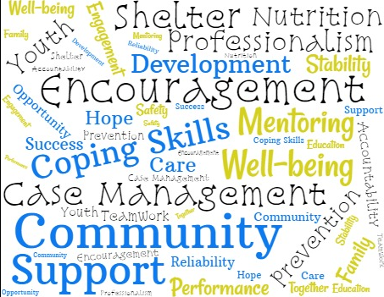
For general questions and day-to-day operations:
Operations Director – Pam Mann
Main: 307-577-5718 Ext. 309
Refer to https://www.casperycc.org/crisis

